Quick Start Guide
B2G V.2 Kiosk Setup
Version 1.0

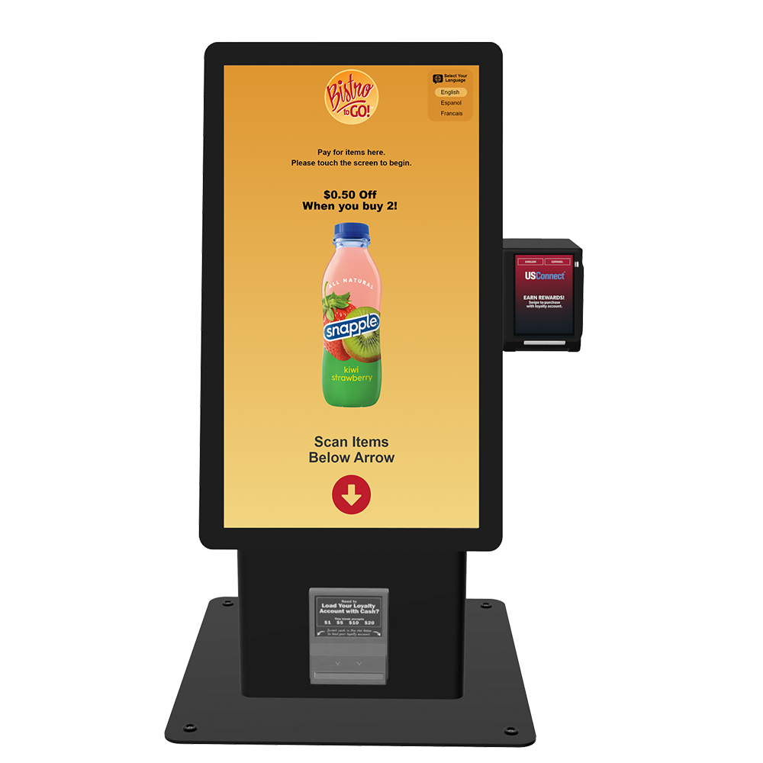

Quick Start Guide

Before You Begin
- Physically inspect the box of your kiosk to ensure no damage occurred during transit.

Step-by-Step Setup
- Unbox the Kiosk
Remove the top foam and place the kiosk on your testing station.
Locate the two keys attached to the 3-prong 110v plug.
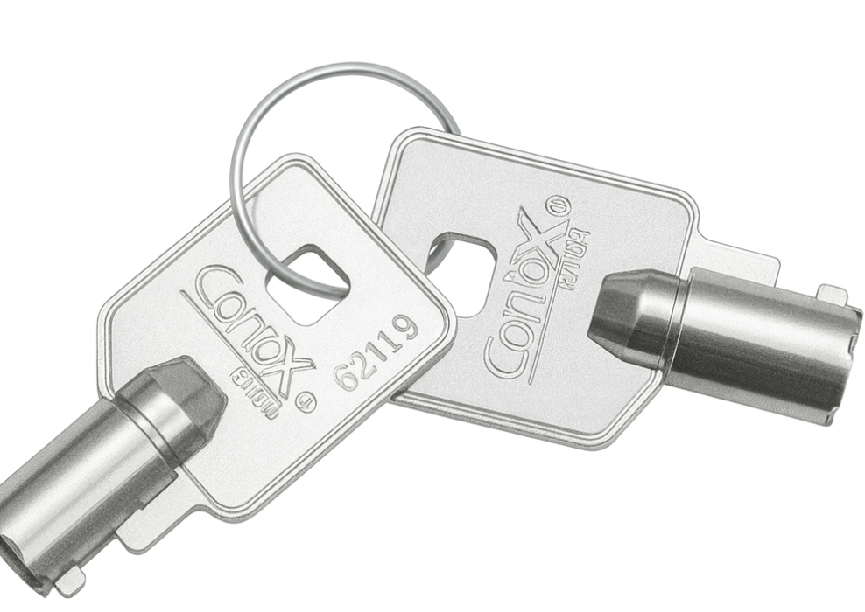
- Open Enclosure
On the right side, using the keys provided, unlock both locks (¼ turn clockwise).
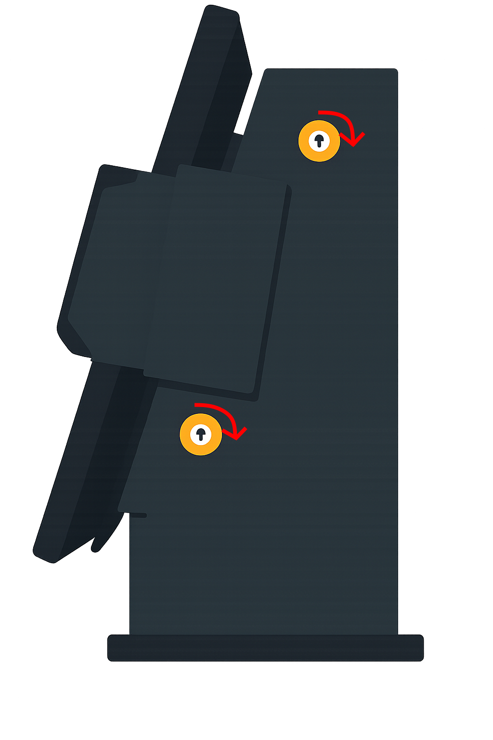
- Antenna Installation
Remove magnetic antennas from the side of the enclosure
Feed them through the two grommets in the back wall.
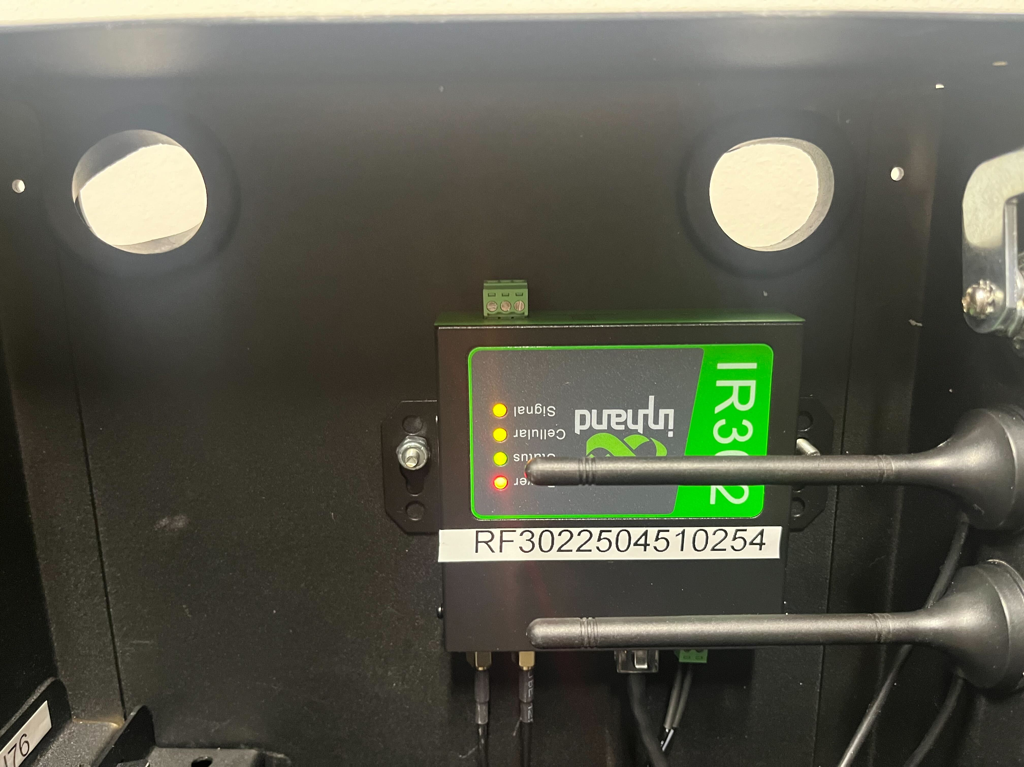
Place antennas on top of the kiosk enclosure from the backside
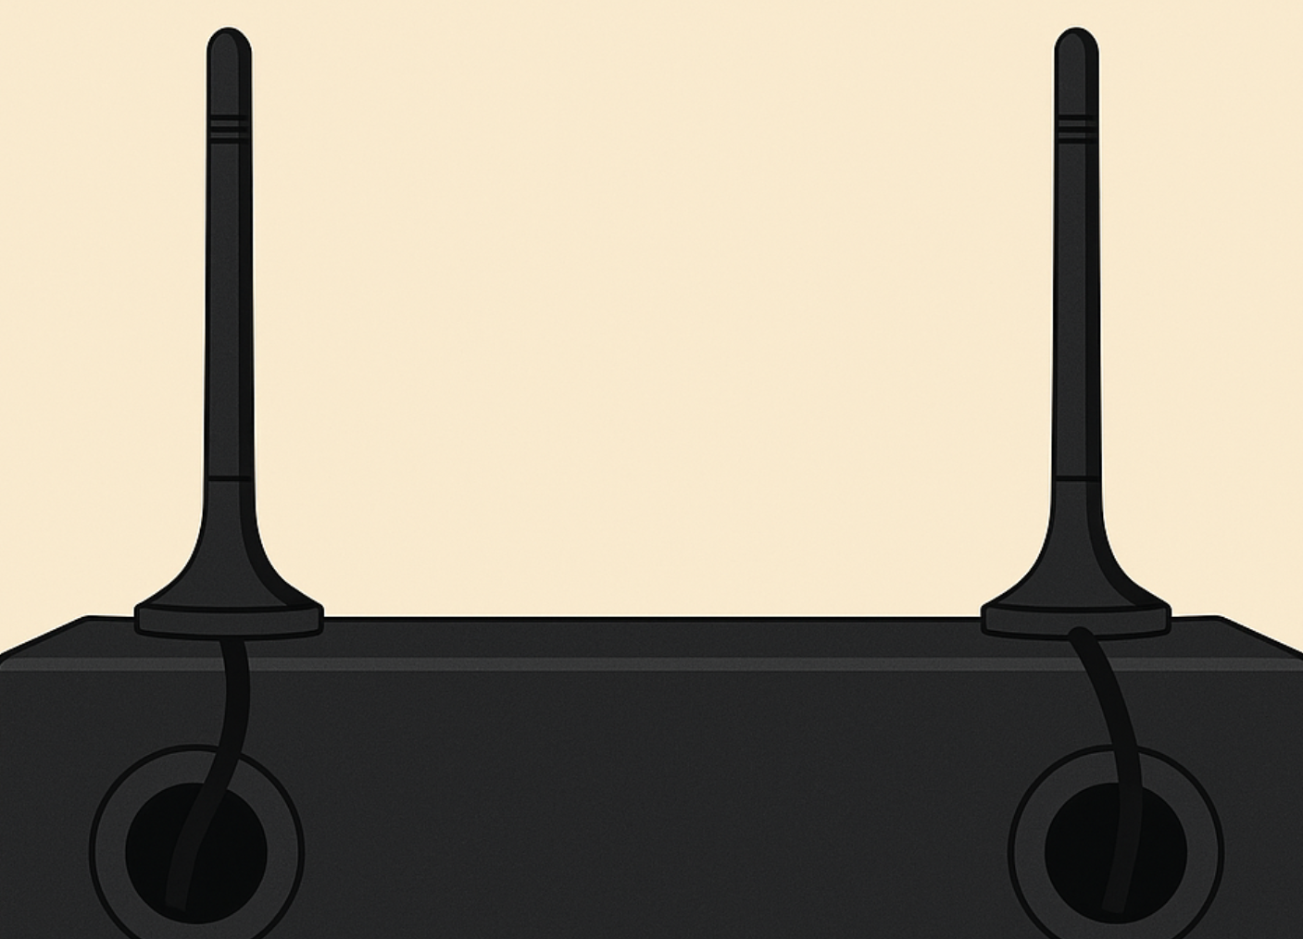

- Wiring Legend
This is also listed on the inside of your kiosk along the back wall. All cables are numbered.
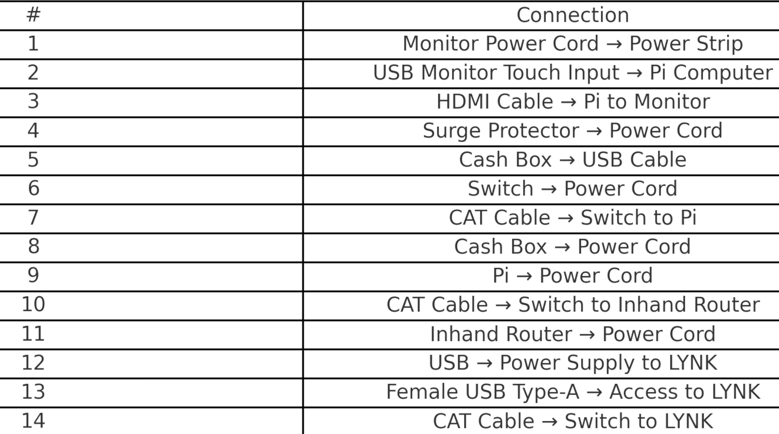
- Plugging in the unit
After plugging the unit in, you should hear the bill validator power on, the touchscreen + barcode scanner should illuminate. The ELO monitor will power on and display the ELO logo.
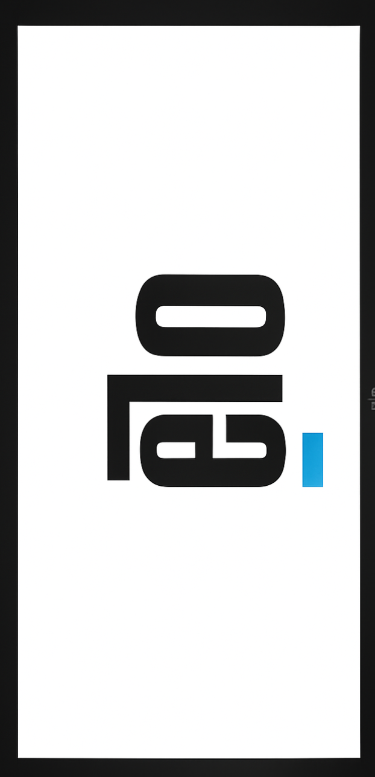
There will be a series of text scroll across the screen to represent the boot up process for the Pi. After several minutes, your kiosk will arrive at the market assignment screen.
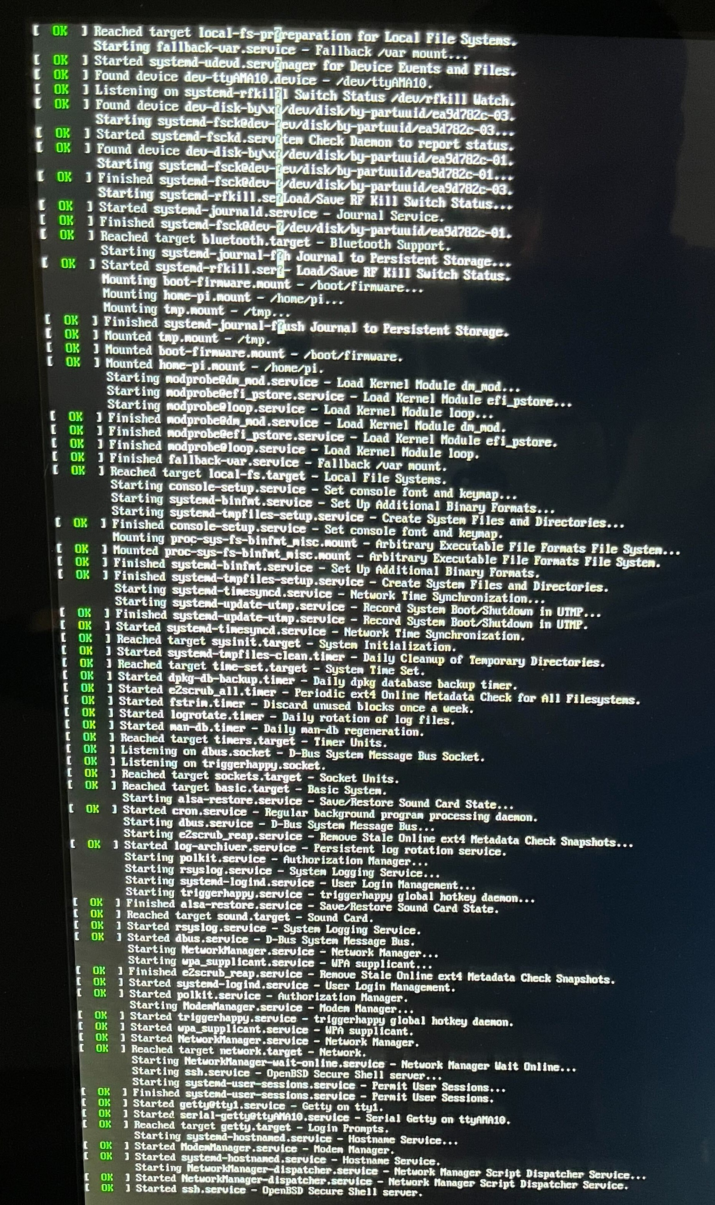
- Raspberry Pi functionality
Check connections on raspberry Pi as well as status LED on the top of the Pi, this should be illuminated Green.
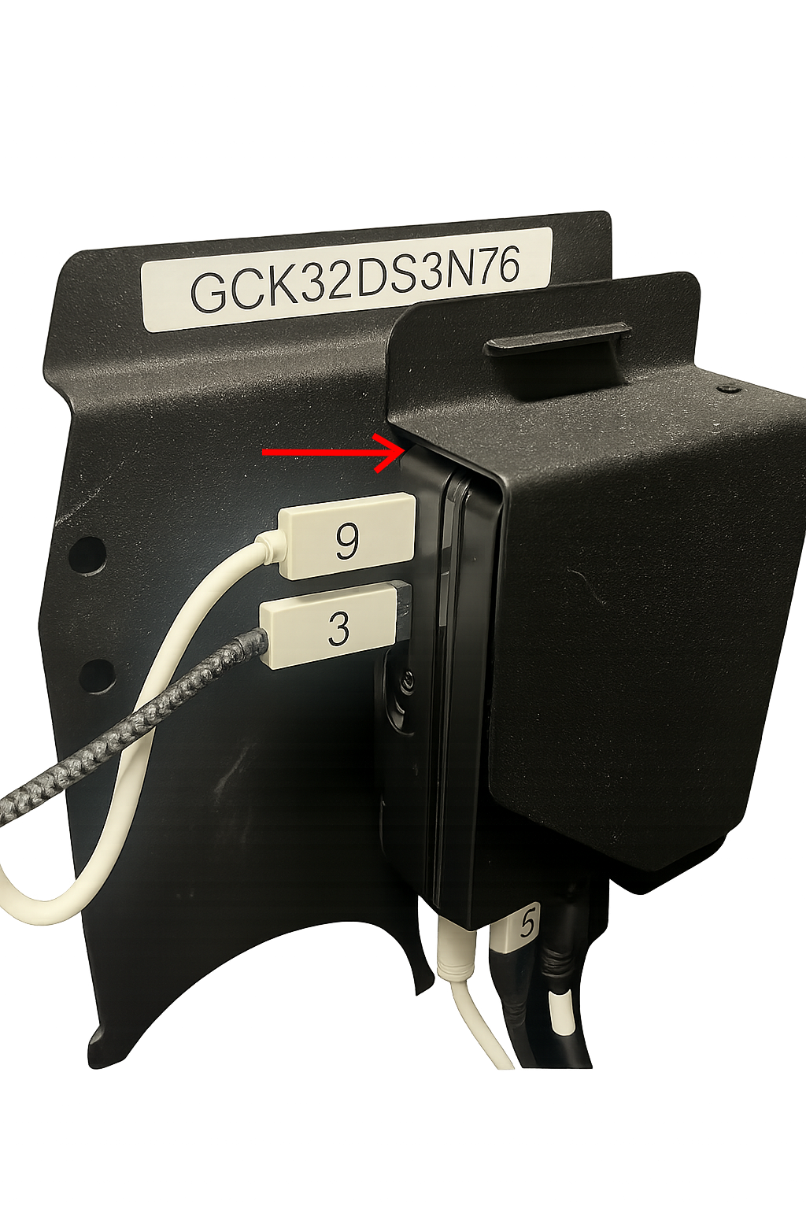
- LYNK Reader functionality
Your LYNK Reader should display the USConnect Screen as illustrated in the graphic below.
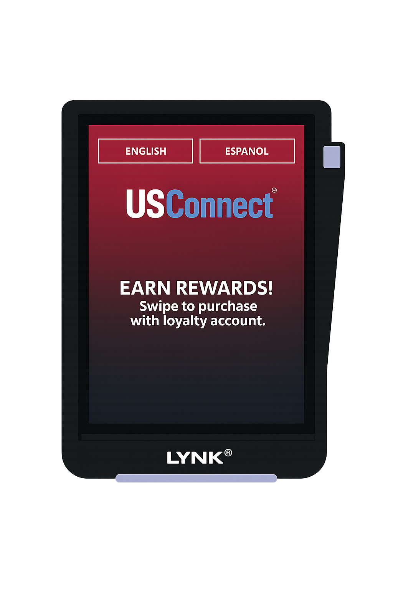
- InHand Modem functionality
Check InHand Modem Lights, your InHand device will be mounted upside down, this is normal. Modem will take several minutes to power on fully. Please allow 3-4 minutes for full boot.
If there is a Globe on the top left of the screen, you do not have internet connectivity. Please wait until this globe disappears.

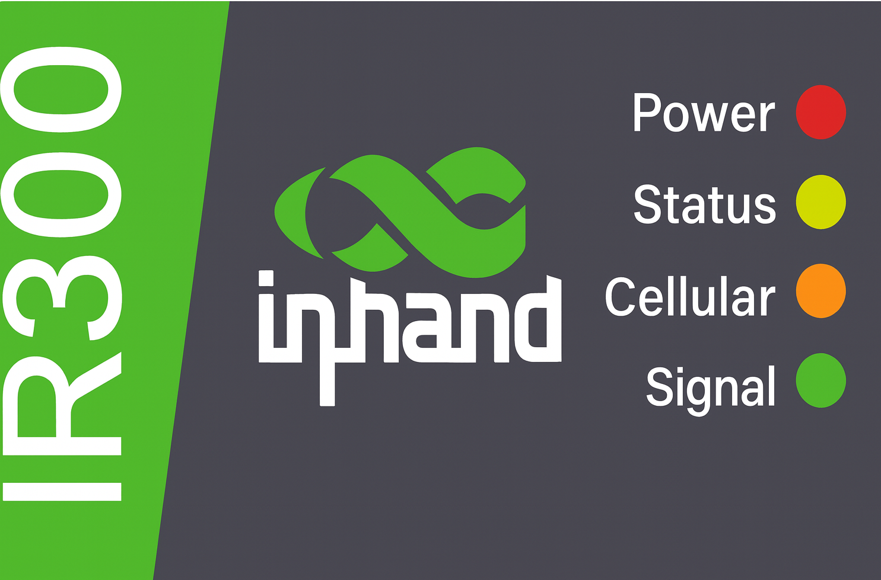
Power – Red = device powered and functioning.
Status – Green = no connectivity/firmware issues.
Cellular – Yellow (blinking) = data passing through network.
Signal – Green = cellular connectivity is active. Yellow = connectivity but not strong connection.
- Lock the enclosure
Lock the kiosk by turning both locks ½ turn counterclockwise.
Press down slightly on monitor while locking kiosk due to rubber bumpers.
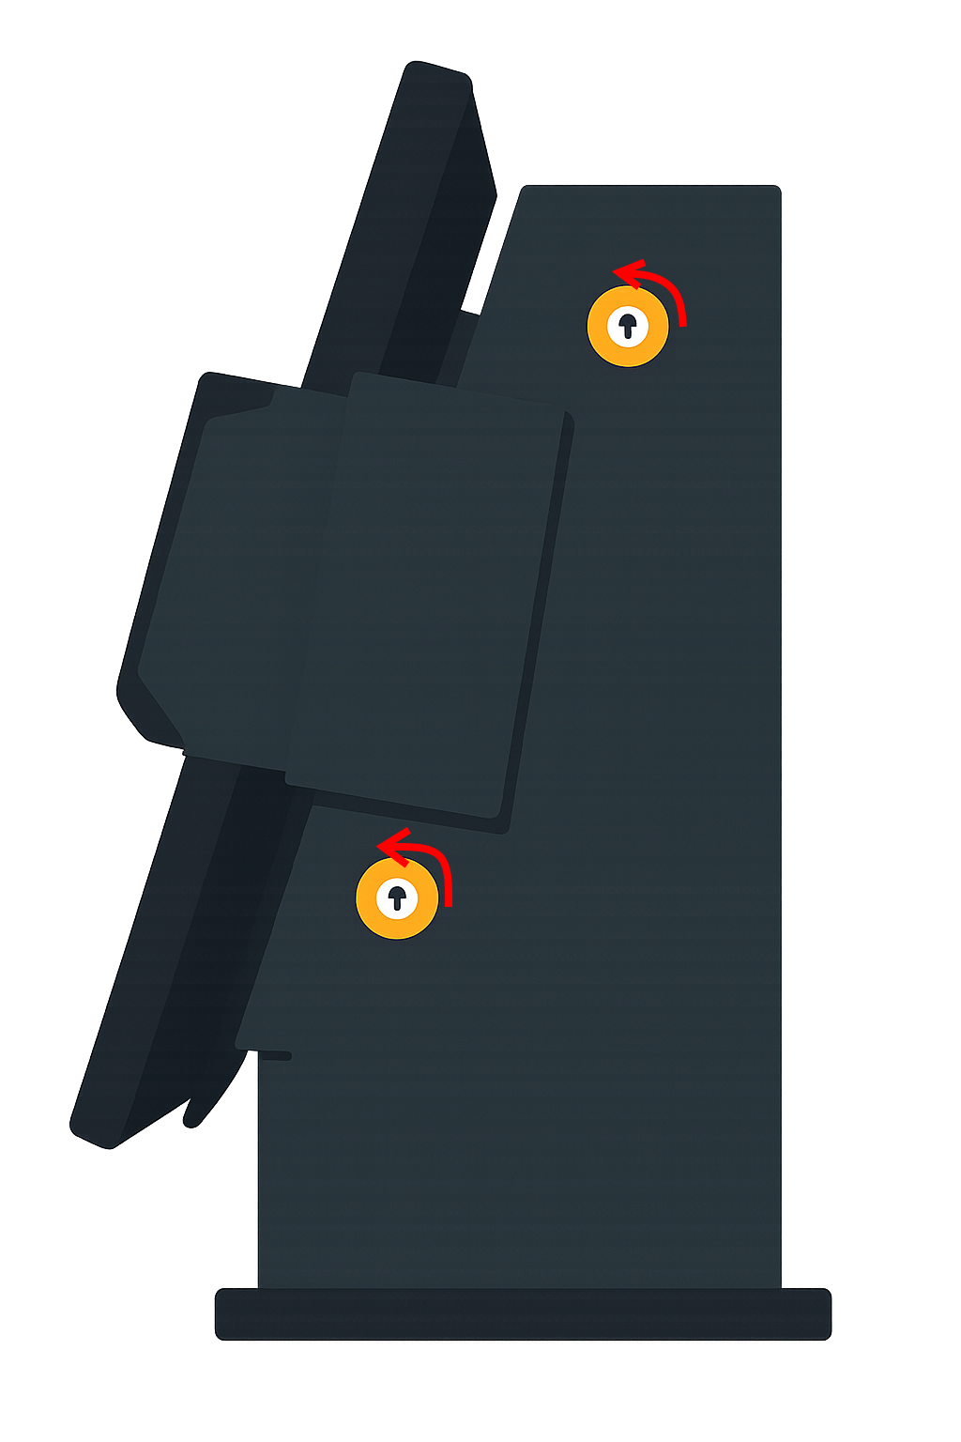
- Assigning to market
- Your Kiosk will be preassigned to you; please follow the onboarding document to attach to your created market in ConnectHQ
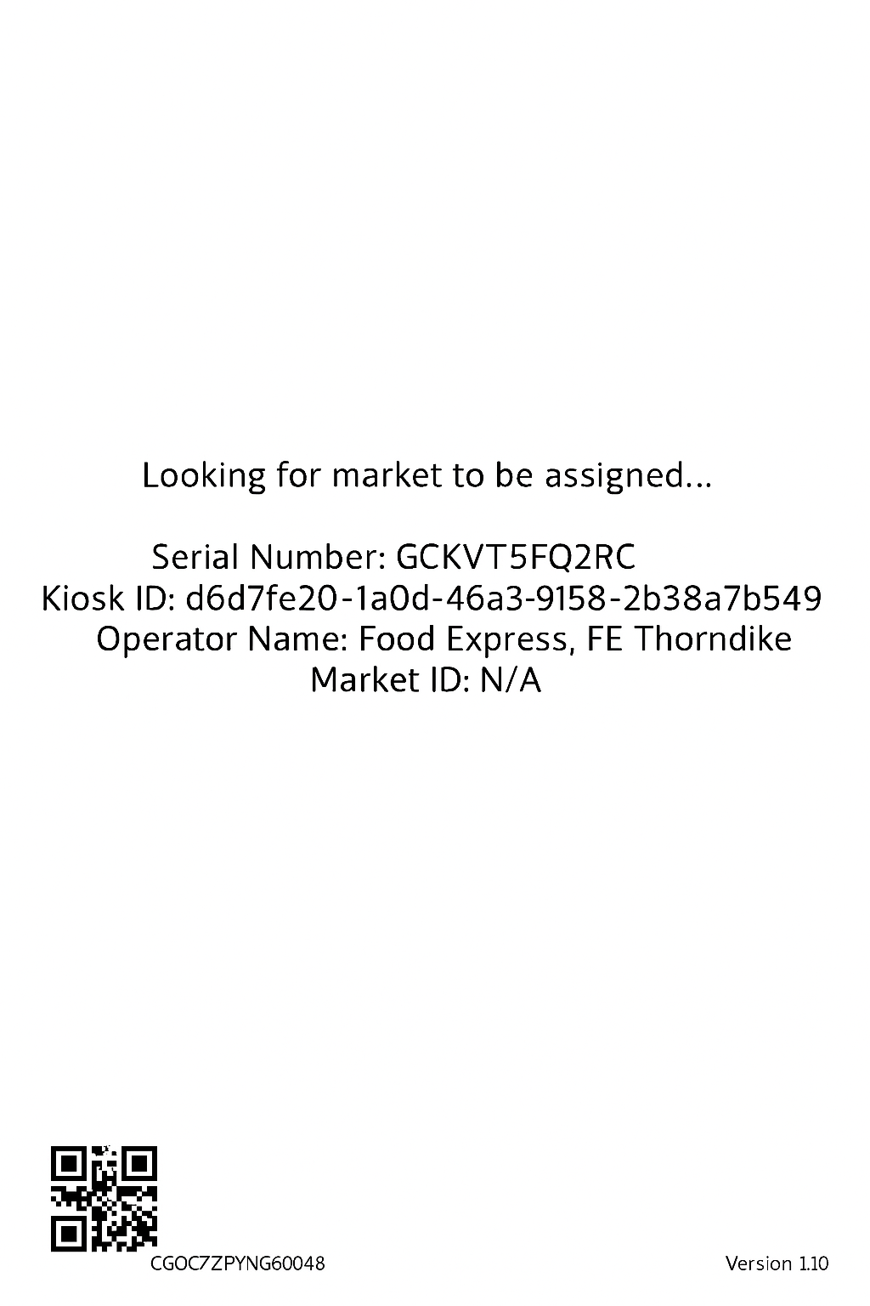

- Test transactions
After your kiosk is assigned to a market, you should see the advertisement screen and begin making test transactions after your product catalog is sent through SEED or CHQ.
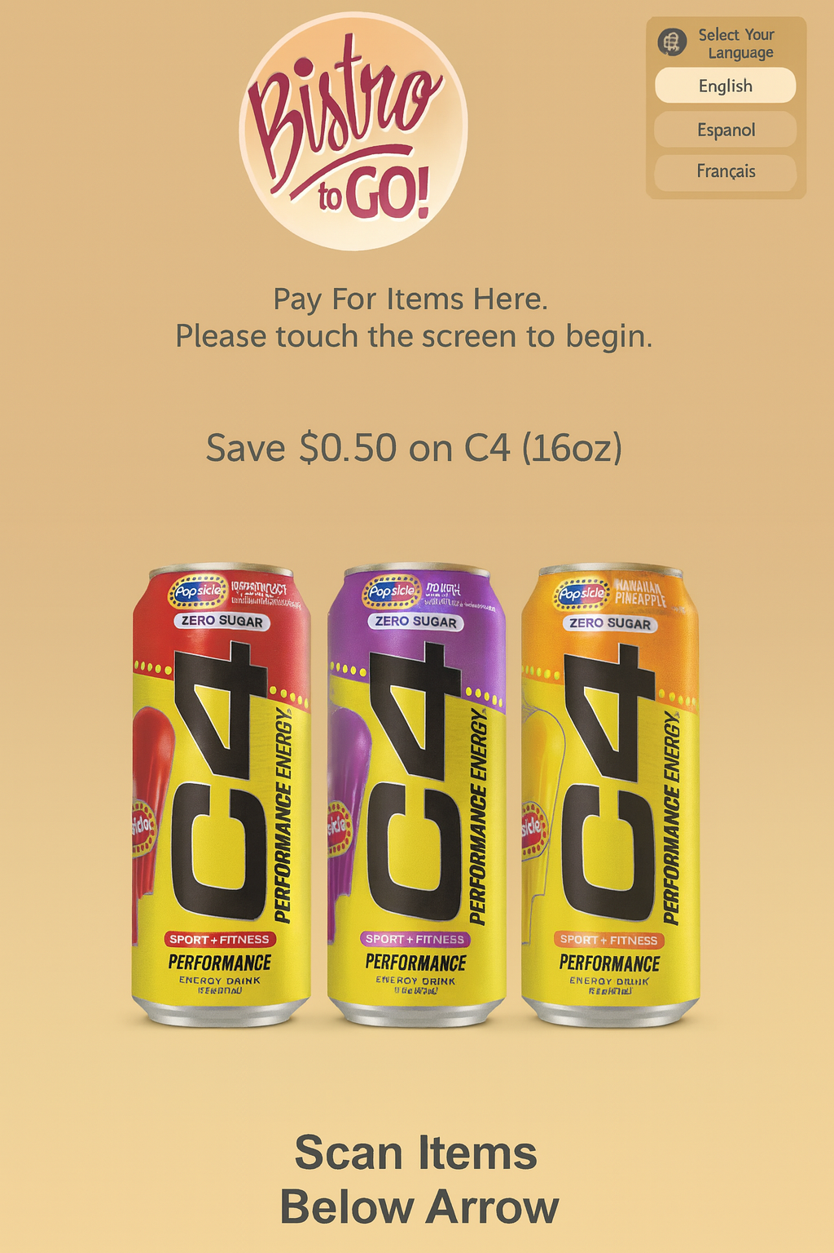
- Accessing the service menu
Using the SERVICE62 Barcode (see attached image) scan the barcode, this will bring up the service menu prompts.
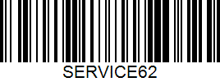
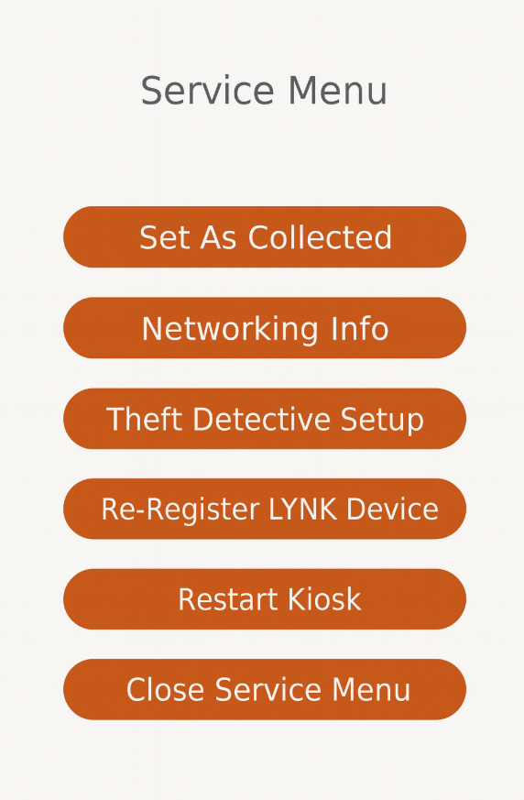
You can also access the service menu by pressing the Black Globe on the top right of the kiosk screen 5 times.
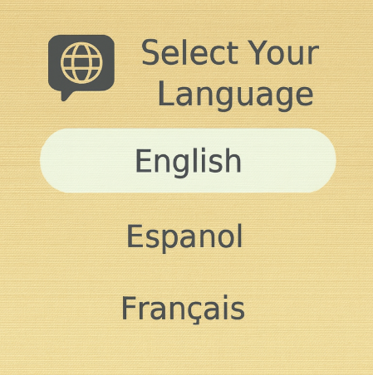

Troubleshooting
If any step fails, contact B2G Support:
📧 B2GSupport@globalconnect.biz
(336)814-8644

